- Make the size of the slides this much like the screenshot below. When you decrease the size of the pictures bring the words and and the picture closer to avoid a big spaces between the picture and words.
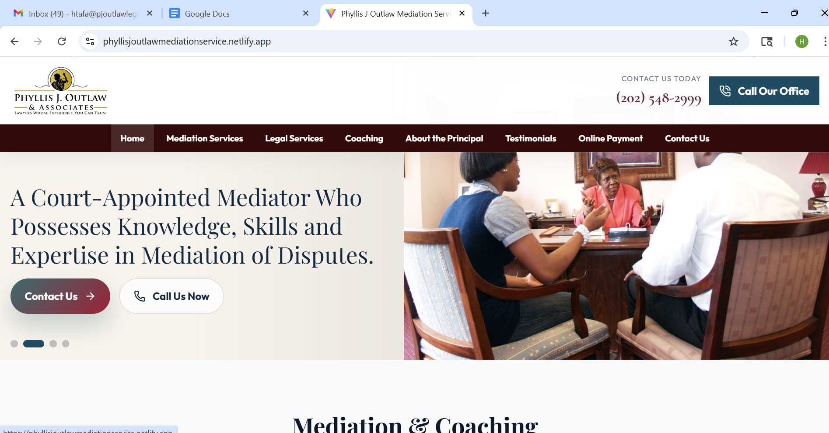
- Use thin line around the pictures like screenshot below 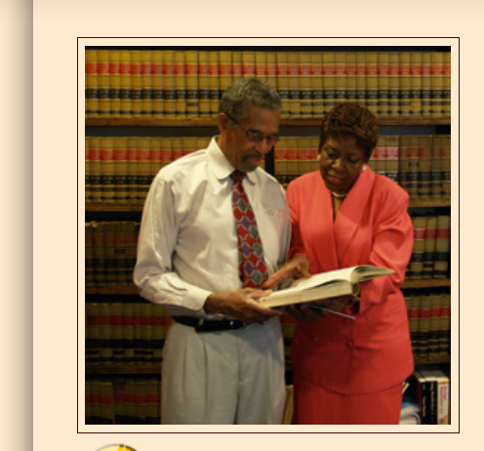
- Use Gold for Menu bar with black font color for text, Website color theme is Burgandy, Blue and Gold, see the attached picture for reference
- When I say burgundy I meant this one, Ilove this section “DO NOT REMOVE ANY SECTIONS, UNLESS YOU’RE TOLD TO DO SO.”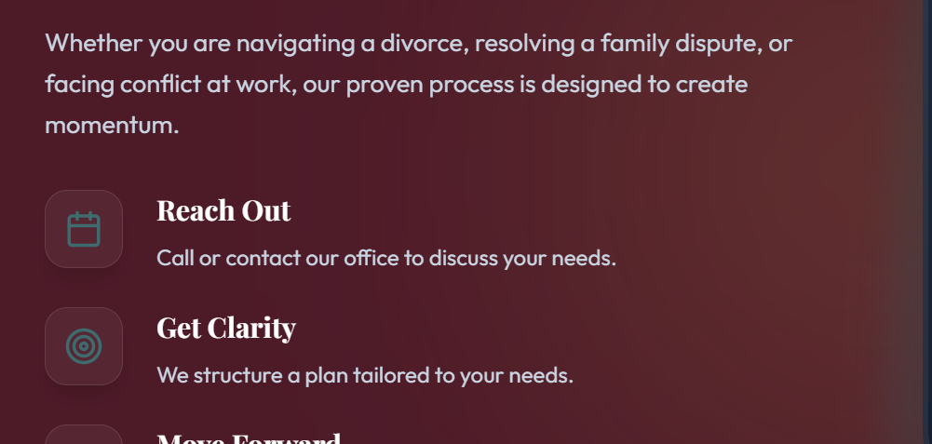
- This is redundant, remove the first one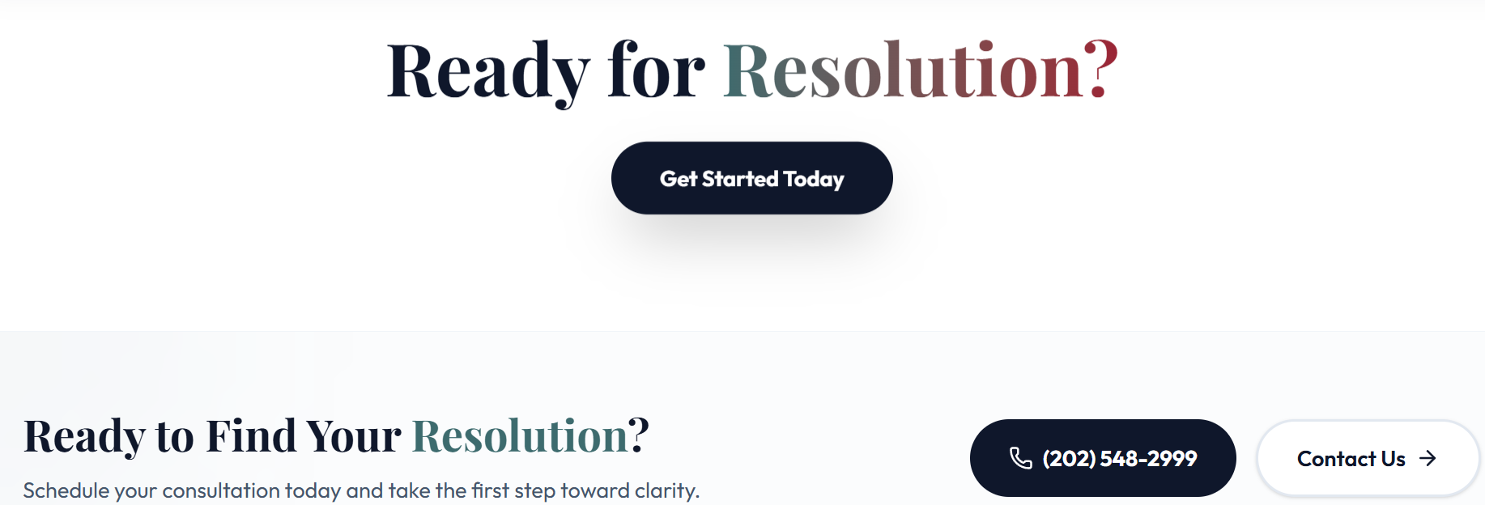
- On the Mediation service tab there is a redundant again, remove the second one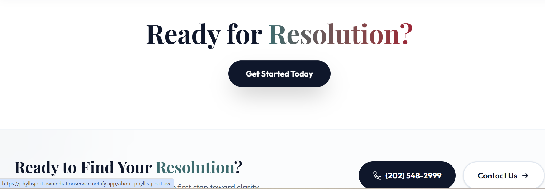
- We don’t need the Testimonial tab. Go ahead and remove that whole section.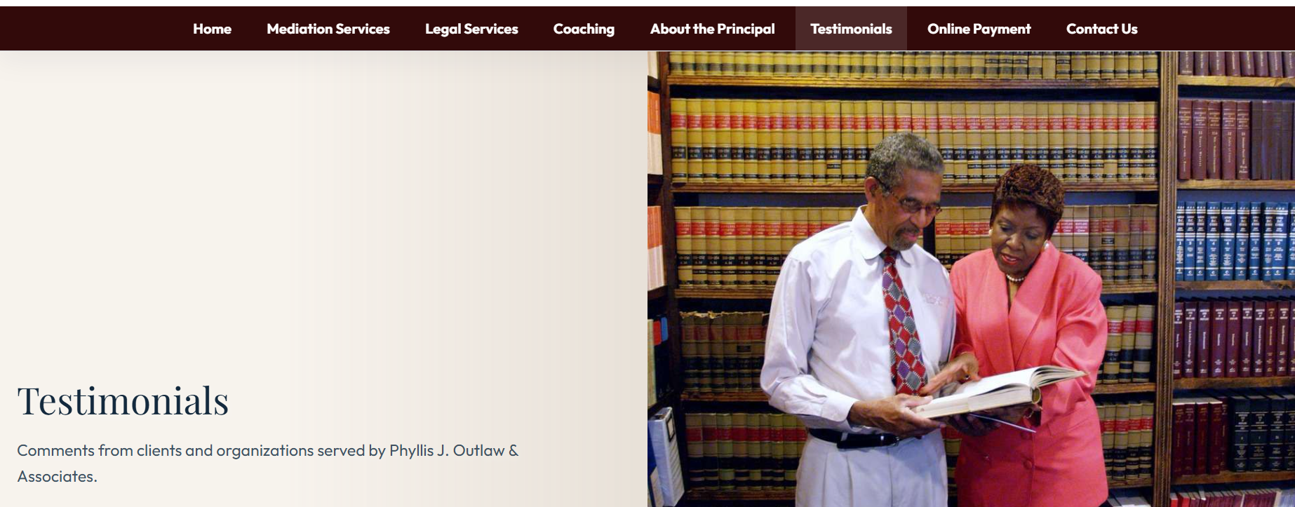
- We don’t want this section on other tabs than the Home page, remove from other tabs.
- (TP 1) Increase the size of the logo to make sure the Moto on the logo is readable.

